**WEB TECHNOLOGIES**

**EXPERIMENT – 5**

**NAME: SAIRANJAN SUBUDHI**

**SAP ID: 500101861**

**ROLL NO: R2142220816**

1. Write a JavaScript program that displays the largest integer among two integers.

**CODE:**

<!DOCTYPE html>

<html lang="en">

<head>

    <meta charset="UTF-8">

    <meta name="viewport" content="width=device-width, initial-scale=1.0">

    <title>Display Largest Integer</title>

    <style>

        body {

            font-family: Arial, sans-serif;

            background-color: #f4f4f4;

            margin: 0;

            padding: 0;

            box-sizing: border-box;

        }

        h1 {

            text-align: center;

            color: #333;

        }

        #integerForm {

            max-width: 400px;

            margin: 0 auto;

            background-color: #fff;

            padding: 20px;

            border-radius: 8px;

            box-shadow: 0 0 10px rgba(0, 0, 0, 0.1);

        }

        label {

            font-weight: bold;

            color: #333;

        }

        input[type="number"] {

            width: 100%;

            padding: 8px;

            margin-top: 6px;

            margin-bottom: 10px;

            border: 1px solid #ccc;

            border-radius: 4px;

            box-sizing: border-box;

        }

        button {

            width: 100%;

            background-color: #4CAF50;

            color: white;

            padding: 10px 20px;

            border: none;

            border-radius: 4px;

            cursor: pointer;

            font-size: 16px;

        }

        button:hover {

            background-color: #45a049;

        }

        #result {

            margin-top: 20px;

            padding: 10px;

            background-color: #fff;

            border: 1px solid #ccc;

            border-radius: 4px;

            box-shadow: 0 0 5px rgba(0, 0, 0, 0.1);

        }

    </style>

</head>

<body>

    <h1>Max Number</h1>

    <form id="integerForm">

        <label for="num1">Enter first integer:</label>

        <input type="number" id="num1" name="num1" required><br><br>

        <label for="num2">Enter second integer:</label>

        <input type="number" id="num2" name="num2" required><br><br>

        <button onclick="findlargest(event)">Find Largest Integer</button>

    </form>

    <div id="result"></div>

    <script>

        function displayLargestInteger(num1, num2) {

            if (num1 > num2) {

                return num1;

            } else {

                return num2;

            }

        }

        function findlargest(e){

            e.preventDefault();

            var num1 = parseInt(document.getElementById("num1").value);

            var num2 = parseInt(document.getElementById("num2").value);

            var result = displayLargestInteger(num1, num2);

            document.getElementById("result").innerHTML = "The largest integer is: " + result; // Displaying the result

        }

    </script>

</body>

</html>

**OUTPUT:**

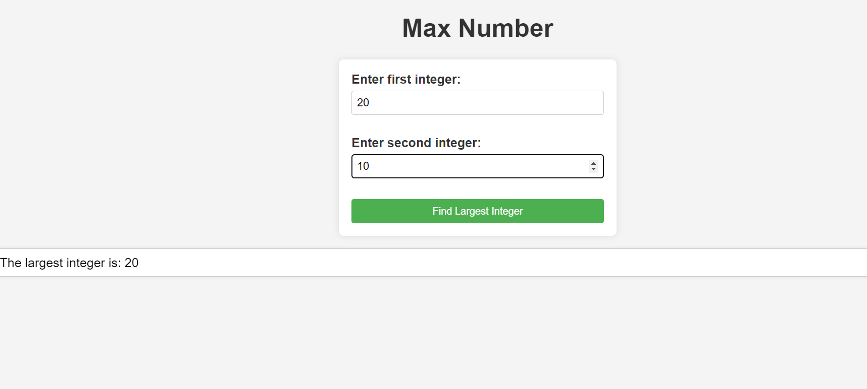

1. Write a JavaScript function that accepts a string as a parameter and converts the first letter of each word into upper case.

**CODE:**

<!DOCTYPE html>

<html lang="en">

<head>

<meta charset="UTF-8">

<meta name="viewport" content="width=device-width, initial-scale=1.0">

<title>Capitalize</title>

<style>

    body {

        font-family: Arial, sans-serif;

        background-color: #f0f0f0;

        margin: 0;

        padding: 0;

    }

    h2 {

        text-align: center;

        color: #333;

    }

    input[type="text"] {

        width: 80%;

        padding: 10px;

        margin: 10px auto;

        display: block;

        border: 1px solid #ccc;

        border-radius: 5px;

        box-sizing: border-box;

    }

    button {

        padding: 10px 20px;

        margin: 10px auto;

        display: block;

        background-color: #4CAF50;

        color: white;

        border: none;

        border-radius: 5px;

        cursor: pointer;

    }

    button:hover {

        background-color: #45a049;

    }

    #output {

        width: 80%;

        margin: 20px auto;

        padding: 10px;

        background-color: #fff;

        border: 1px solid #ccc;

        border-radius: 5px;

    }

</style>

<script>

function capitalizeFirstLetterOfEachWord(str) {

    return str.replace(/\b\w/g, function(char) {

 /* \b\w matches the first character of each word in the string. The \b ensures that it matches at the beginning of a word, and \w matches any word character.

 /g ensures that this pattern is applied globally, so it finds all occurrences of the pattern */

        return char.toUpperCase();

    });

}

function capitalizeAndDisplay() {

    let inputText = document.getElementById("inputText").value;

    let capitalizedText = capitalizeFirstLetterOfEachWord(inputText);

    document.getElementById("output").innerText = capitalizedText;

}

</script>

</head>

<body>

<h2>Capitalize first letter of each word</h2>

<input type="text" id="inputText" placeholder="Enter a sentence">

<button onclick="capitalizeAndDisplay()">Capitalize</button>

<div id="output"></div>

</body> </html>

**OUTPUT:**

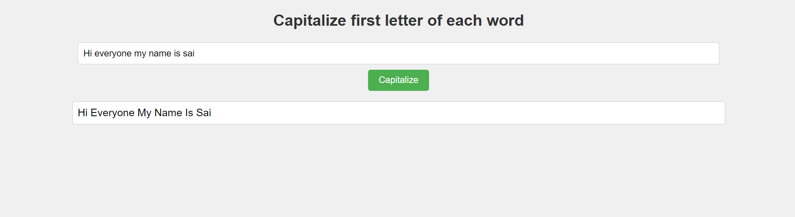

1. Write a Java Script to create a simple calculator.

**CODE:**

<!DOCTYPE html>

<html lang="en">

<head>

<meta charset="UTF-8">

<meta name="viewport" content="width=device-width, initial-scale=1.0">

<title>Simple Calculator</title>

<style>

    body {

        font-family: Arial, sans-serif;

        background-color: #f0f0f0;

        margin: 0;

        padding: 0;

    }

    h2 {

        text-align: center;

        color: #333;

    }

    .calculator {

        width: 300px;

        margin: 20px auto;

        padding: 10px;

        background-color: #fff;

        border-radius: 8px;

        box-shadow: 0 0 10px rgba(0, 0, 0, 0.1);

    }

    #display {

        width: 100%;

        margin-bottom: 10px;

        padding: 3.5px;

        font-size: 20px;

        text-align: right;

        border: 1px solid #ccc;

        border-radius: 4px;

        margin-right: 30px;

    }

    .btn-container {

        display: grid;

        grid-template-columns: repeat(4, 1fr);

        grid-gap: 5px;

    }

    input[type="button"] {

        padding: 10px;

        font-size: 20px;

        background-color: #4CAF50;

        color: white;

        border: none;

        border-radius: 4px;

        cursor: pointer;

    }

    input[type="button"]:hover {

        background-color: #45a049;

    }

</style>

</head>

<body>

<h2>Simple Calculator</h2>

<div class="calculator">

    <input type="text" id="display" disabled>

    <div class="btn-container">

        <input type="button" value="1" onclick="appendToDisplay('1')">

        <input type="button" value="2" onclick="appendToDisplay('2')">

        <input type="button" value="3" onclick="appendToDisplay('3')">

        <input type="button" value="+" onclick="appendToDisplay('+')">

        <input type="button" value="4" onclick="appendToDisplay('4')">

        <input type="button" value="5" onclick="appendToDisplay('5')">

        <input type="button" value="6" onclick="appendToDisplay('6')">

        <input type="button" value="-" onclick="appendToDisplay('-')">

        <input type="button" value="7" onclick="appendToDisplay('7')">

        <input type="button" value="8" onclick="appendToDisplay('8')">

        <input type="button" value="9" onclick="appendToDisplay('9')">

        <input type="button" value="*" onclick="appendToDisplay('*')">

        <input type="button" value="C" onclick="clearDisplay()">

        <input type="button" value="0" onclick="appendToDisplay('0')">

        <input type="button" value="=" onclick="calculate()">

        <input type="button" value="/" onclick="appendToDisplay('/')">

    </div>

</div>

<script>

function appendToDisplay(value) {

    document.getElementById('display').value += value;

}

function clearDisplay() {

    document.getElementById('display').value = '';

}

function calculate() {

    let expression = document.getElementById('display').value;

    let result = eval(expression); /*built in JS func */

    document.getElementById('display').value = result;

}

</script>

</body>

</html>

**OUTPUT:**

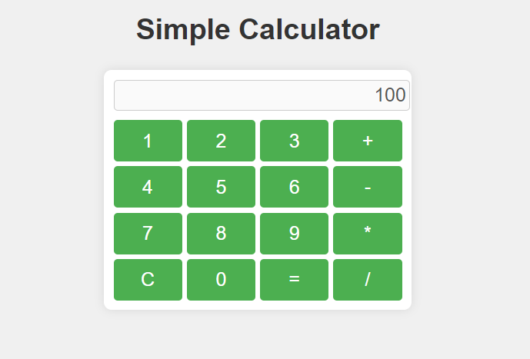

1. Write a JavaScript function that accepts a string as a parameter and finds the longest word within the string.

**CODE:**

<!DOCTYPE html>

<html lang="en">

<head>

  <meta charset="UTF-8">

  <meta name="viewport" content="width=device-width, initial-scale=1.0">

  <title>Longest Word Finder</title>

  <style>

    body {

      font-family: Arial, sans-serif;

      background-color: #f0f0f0;

      margin: 0;

      padding: 0;

    }

    #container {

      width: 80%;

      margin: 50px auto;

      text-align: center;

    }

    input[type="text"] {

      width: 100%;

      padding: 10px;

      margin-bottom: 10px;

      box-sizing: border-box;

    }

    button {

      padding: 10px 20px;

      font-size: 16px;

      background-color: #4CAF50;

      color: white;

      border: none;

      border-radius: 5px;

      cursor: pointer;

    }

    button:hover {

      background-color: #45a049;

    }

    #result {

      margin-top: 20px;

    }

  </style>

</head>

<body>

<div id="container">

  <h2>Longest Word Finder</h2>

  <input type="text" id="inputString" placeholder="Enter your sentence here">

  <button type="button" onclick="findLongestWord()">Find Longest Word</button>

  <p id="result"></p>

</div>

<script>

  function findLongestWord() {

    const inputString = document.getElementById("inputString").value.trim();

    if (!inputString) {

      alert("Please enter a sentence.");

      return;

    }

    const words = inputString.split(/\s+/); /*\s+ matches one or more whitespace characters */

    let longestWord = "";

    let longestWordLength = 0;

    for (const word of words) {

      if (word.length > longestWordLength) {

        longestWord = word;

        longestWordLength = word.length;

      }

    }

    const resultElement = document.getElementById("result");

    resultElement.textContent = `The longest word is: "${longestWord}"`;

  }

</script>

</body>

</html>

**OUTPUT:**

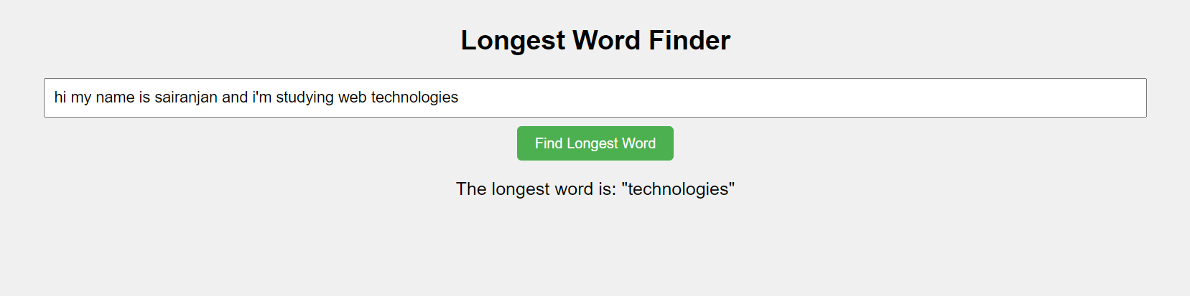

1. Write a JavaScript program to find odd and even numbers from 1 to 100.

**CODE:**

<!DOCTYPE html>

<html lang="en">

<head>

  <meta charset="UTF-8">

  <meta name="viewport" content="width=device-width, initial-scale=1.0">

  <title>Odd and Even Numbers</title>

  <style>

    body {

      font-family: Arial, sans-serif;

      margin: 0;

      padding: 0;

      background-color: #f4f4f4;

    }

    h1 {

      text-align: center;

    }

    button {

      display: block;

      margin: 20px auto;

      padding: 10px 20px;

      font-size: 16px;

      border: none;

      background-color: #007bff;

      color: #fff;

      cursor: pointer;

    }

    button:hover {

      background-color: #0056b3;

    }

    #results {

      max-width: 600px;

      margin: 0 auto;

      padding: 20px;

      background-color: #fff;

      border-radius: 5px;

      box-shadow: 0 0 10px rgba(0, 0, 0, 0.1);

    }

    h3 {

      margin-top: 0;

    }

    p {

      margin: 0;

    }

  </style>

</head>

<body>

  <h1>Finding Odd and Even Numbers</h1>

  <button onclick="checkNumbers()">Check Numbers</button>

  <div id="results"></div>

  <script>

    function checkNumbers() {

      const results = document.getElementById("results");

      results.innerHTML = ""; // Clear previous results

      let evenNumbers = "";

      let oddNumbers = "";

      for (let i = 1; i <= 100; i++) {

        if (i % 2 === 0) {

          evenNumbers += i + " ";

        } else {

          oddNumbers += i + " ";

        }

      }

      results.innerHTML = `<h3>Even Numbers:</h3> <p>${evenNumbers}</p> <br> <h3>Odd Numbers:</h3> <p>${oddNumbers}</p>`;

    }

  </script>

</body>

</html>

**OUTPUT:**

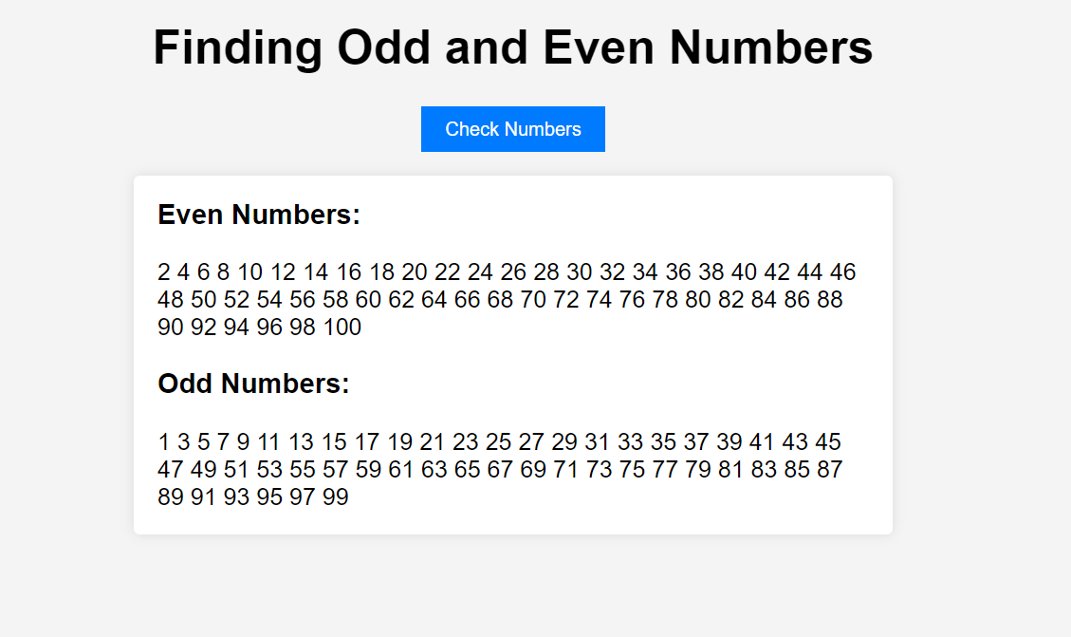

1. Write a JavaScript program to generate a random string.

**CODE:**

<!DOCTYPE html>

<html lang="en">

<head>

  <meta charset="UTF-8">

  <meta name="viewport" content="width=device-width, initial-scale=1.0">

  <title>Random String Generator</title>

  <style>

    body {

      font-family: Arial, sans-serif;

      margin: 0;

      padding: 0;

      background-color: #f4f4f4;

    }

    h1 {

      text-align: center;

    }

    input[type="number"] {

      display: block;

      margin: 20px auto;

      padding: 10px;

      font-size: 16px;

      width: 200px;

      border: 1px solid #ccc;

      border-radius: 5px;

      box-sizing: border-box;

    }

    button {

      display: block;

      margin: 10px auto;

      padding: 10px 20px;

      font-size: 16px;

      border: none;

      background-color: #007bff;

      color: #fff;

      cursor: pointer;

      border-radius: 5px;

    }

    button:hover {

      background-color: #0056b3;

    }

    p#result {

      text-align: center;

      margin-top: 20px;

      font-size: 18px;

    }

  </style>

</head>

<body>

  <h1>Generate a Random String</h1>

  <input type="number" id="stringLength" placeholder="Enter String Length">

  <button onclick="generateString()">Generate</button>

  <p id="result"></p>

  <script>

    function generateString() {

      const stringLength = document.getElementById("stringLength").value;

      const result = document.getElementById("result");

      if (stringLength === "" || isNaN(stringLength) || stringLength <= 0) {

        result.textContent = "Please enter a valid positive number for string length.";

        return;

      }

      const characters = "ABCDEFGHIJKLMNOPQRSTUVWXYZabcdefghijklmnopqrstuvwxyz0123456789";

      let randomString = "";

      for (let i = 0; i < stringLength; i++) {

        const randomIndex = Math.floor(Math.random() * characters.length);

        randomString += characters.charAt(randomIndex);

      }

      result.textContent = "Your random string is: " + randomString;

    }

  </script>

</body>

</html>

**OUTPUT:**

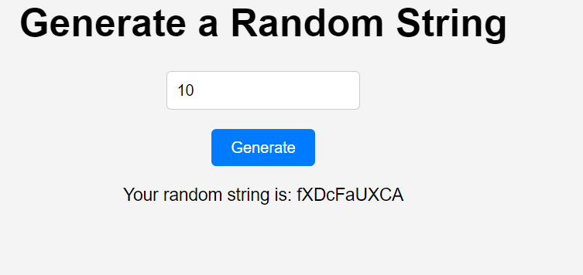

1. Write a JavaScript Program to Print All Prime Numbers in an Interval.

**CODE:**

<!DOCTYPE html>

<html lang="en">

<head>

  <meta charset="UTF-8">

  <meta name="viewport" content="width=device-width, initial-scale=1.0">

  <title>Prime Number Finder</title>

  <style>

    body {

      font-family: Arial, sans-serif;

      margin: 0;

      padding: 0;

      background-color: #f4f4f4;

      margin-left: 4px;

    }

    h1 {

      text-align: center;

    }

    label {

      display: block;

      margin-top: 10px;

    }

    input[type="number"] {

      display: block;

      margin-bottom: 10px;

      padding: 5px;

      width: calc(25% - 5px);

      box-sizing: border-box;

      margin-left:3px ;

    }

    button {

      display: block;

      margin: 10px auto;

      padding: 10px 20px;

      font-size: 16px;

      border: none;

      background-color: #007bff;

      color: #fff;

      cursor: pointer;

      border-radius: 5px;

    }

    button:hover {

      background-color: #0056b3;

    }

    p#result {

      text-align: center;

      margin-top: 20px;

      font-size: 18px;

    }

  </style>

</head>

<body>

  <h1>Find Prime Numbers</h1>

  <label for="lowerLimit">Lower Limit:</label> <br>

  <input type="number" id="lowerLimit" placeholder="Enter lower limit"> <br>

  <label for="upperLimit">Upper Limit:</label> <br>

  <input type="number" id="upperLimit" placeholder="Enter upper limit">

  <button onclick="findPrimes()">Find Primes</button>

  <p id="result"></p>

  <script>

    function isPrime(num) {

      if (num <= 1) {

        return false;

      }

      for (let i = 2; i <= Math.sqrt(num); i++) {

        if (num % i === 0) {

          return false;

        }

      }

      return true;

    }

    function findPrimes() {

      const lowerLimit = parseInt(document.getElementById("lowerLimit").value);

      const upperLimit = parseInt(document.getElementById("upperLimit").value);

      const result = document.getElementById("result");

      result.textContent = "Prime numbers between " + lowerLimit + " and " + upperLimit + " are:";

      for (let i = lowerLimit; i <= upperLimit; i++) {

        if (isPrime(i)) {

          result.textContent += " " + i;

        }

      }

    }

  </script>

</body>

</html>

**OUTPUT:**

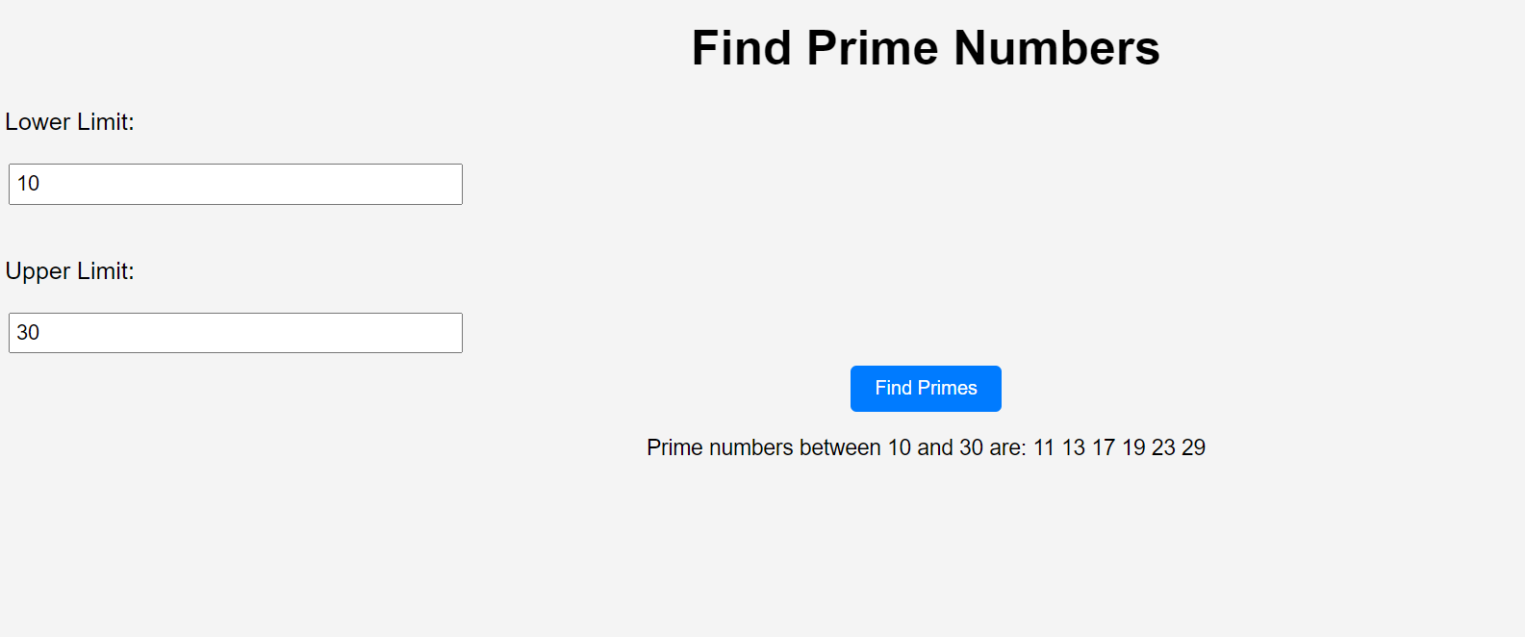

1. Write a JavaScript program to populate a drop-down box from 1 to 1000.

**CODE:**

<!DOCTYPE html>

<html lang="en">

<head>

  <meta charset="UTF-8">

  <meta name="viewport" content="width=device-width, initial-scale=1.0">

  <title>Number Dropdown</title>

  <style>

    body {

      font-family: Arial, sans-serif;

      margin: 0;

      padding: 0;

      background-color: #f4f4f4;

    }

    h1 {

      text-align: center;

    }

    select {

      display: block;

      margin: 20px auto;

      padding: 10px;

      font-size: 16px;

      width: 200px;

      border: 1px solid #ccc;

      border-radius: 5px;

      box-sizing: border-box;

    }

  </style>

</head>

<body>

  <h1>Select a Number</h1>

  <select id="numberDropdown"></select>

  <script>

    const dropdown = document.getElementById("numberDropdown");

    function populateDropdown() {

      for (let i = 1; i <= 1000; i++) {

        const option = document.createElement("option");

        option.value = i;

        option.text = i;

        dropdown.appendChild(option);

      }

    }

    populateDropdown();

  </script>

</body>

</html>

**OUTPUT:**

